SIMATS ENGINEERING (SAVEETHA SCHOOL OF ENGINEERING)
Department of Computer Science and Engineering
CO2_AT3 — CASE STUDY

Course Code: | DSA06 | Course Title: | Data Handling and Visualization
CO Assessed: | CO2 – Evaluation (BL5) | Assessment: | Assessment Tool 3 – Case Study
Weightage: | 20% of CIA | Total Marks: | 20 (2 Questions × 10 Marks)
CO2 Statement: | Analyze real-world data scenarios and evaluate/justify the most appropriate chart types, coordinate systems, color scales, and dashboard designs to represent them.(BL5)
Student Name: | A M RAKESH | Reg. No.: | 192424393
Section / Batch: | AIDS/2024 | Date: | 04/08/2026

Code of Conduct
I A M RAKESH / 192424393 (Name / Reg No) certify that this submission is my original work and that I have adhered to the guidelines specified for this assessment. I understand that any violation of academic integrity rules will result in disciplinary action.

Signature of the Student: A M RAKESH

Instructions
- This test contains 2 case-study questions, each carrying 10 marks. Total: 20 Marks.
- No negative marking. Unanswered questions carry zero marks.
- No calculators or electronic devices permitted.
- Duration: 90 minutes.
- Each case study has four sub-parts (a–d); answer all parts for full marks.
- Support your answers with brief calculations or justifications where relevant.
- Diagrams may be hand-drawn or clearly described in words if drawing tools are unavailable.

Annexure A – CASE STUDY

Rubrics for Calculation ASSESSMENT RUBRIC
AT3 — Case Study
CO2 · BT5: Evaluate ·
This rubric is used to assess student responses to the CO2-AT3 Case Study questions, in which students analyze a realistic multi-part scenario and select, justify, design, and critique appropriate visualizations across chart types, coordinate systems, color scales, and dashboard development.

Criteria | Weightage | Level 4 – Exemplary | Level 3 – Proficient | Level 2 – Developing | Level 1 – Beginning
Understanding of Concepts | 25% | Demonstrates thorough understanding of the full range of chart types, coordinate systems, and color scales relevant to the case, and correctly identifies which apply to each sub-part. | Good understanding of the relevant concepts, with only minor gaps in identifying appropriate chart types, scales, or color choices. | Basic understanding, but with some misconceptions about which visualization techniques suit the scenario's data. | Poor understanding of core concepts; proposes techniques fundamentally unsuited to the case study's data.
Explanation | 25% | Provides detailed, well-reasoned justification for every design decision and critique, explicitly tied to specific details of the case. | Provides clear justification for most decisions and critiques, with adequate reasoning. | Justification is limited or generic; decisions are stated without sufficient reasoning tied to the case. | Little or no justification provided; answers are unsupported assertions.
Application | 20% | Effectively applies visualization concepts to analyze and solve every sub-part of the case, including any calculations, with well-reasoned conclusions. | Applies concepts correctly to most sub-parts, with only minor errors. | Limited application; some sub-parts are weakly addressed or only partially correct. | Fails to apply appropriate concepts; sub-parts are left unaddressed or answered incorrectly.
Organization | 15% | The response is clearly structured, addressing every sub-part (a–d) in a logical sequence with coherent overall flow. | The response is organized and addresses each sub-part, with only minor issues in flow or clarity. | Basic structure; sub-parts are addressed but the response lacks clarity or a logical sequence. | Poorly organized; the response is incoherent, and sub-parts are left unaddressed or answered out of order.
Accuracy | 10% | All parts of the answer — chart choices, calculations, critiques, and dashboard design — are completely accurate and well-suited to the case. | Mostly accurate, with only minor omissions or a small error in one sub-part. | Partially correct; some elements are missing, mismatched to the case, or incorrect. | Largely incorrect or inappropriate, with major gaps across multiple sub-parts.

Scoring Guide
For each criterion, award a performance level (1–4) based on the descriptors above. Multiply the level achieved (as a percentage of 4, i.e., Level 4 = 100%, Level 3 = 75%, Level 2 = 50%, Level 1 = 25%) by the criterion's weightage, then sum across all five criteria to obtain the total score out of 100%.

Faculty In-charge | Course Coordinator | Head of Department
Signature: _______________ | Signature: _______________ | Signature: _______________
Date: ___________________ | Date: ___________________ | Date: ___________________

5.
a) What type of color scale is required for the temperature anomaly map, and why?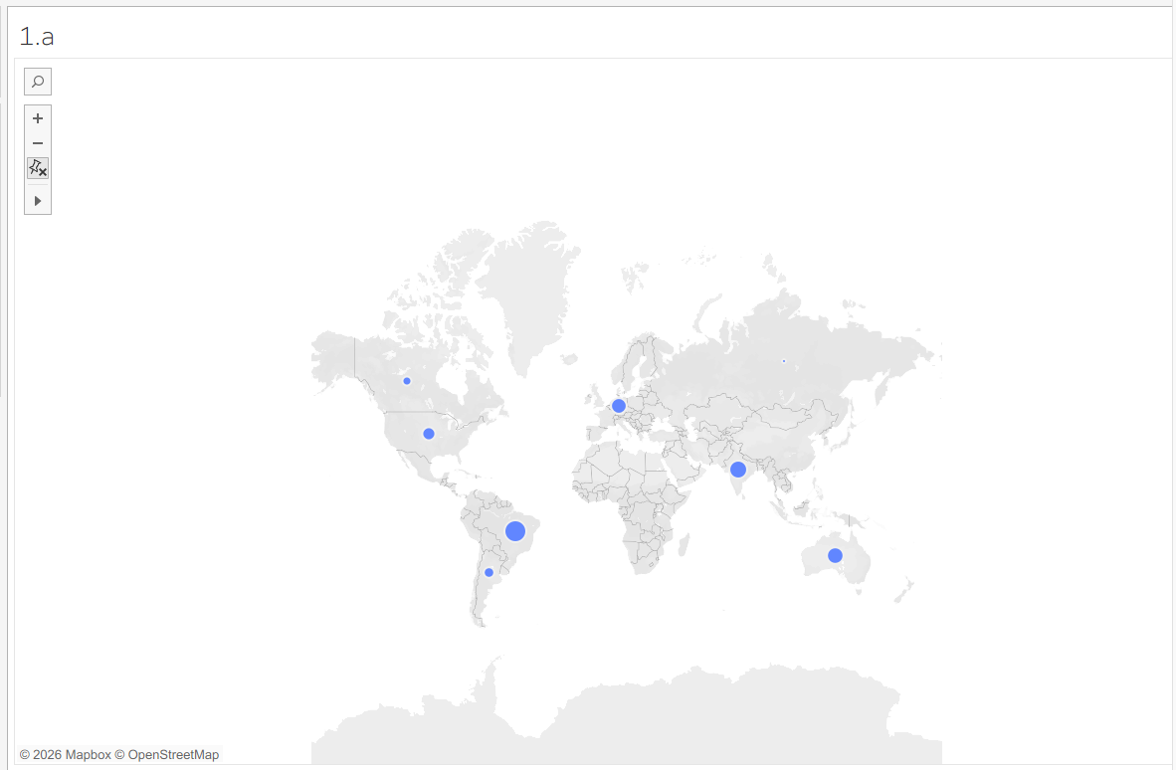
b) Propose a chart for the 5-year AQI trend, and explain how you would handle large seasonal swings in the data. 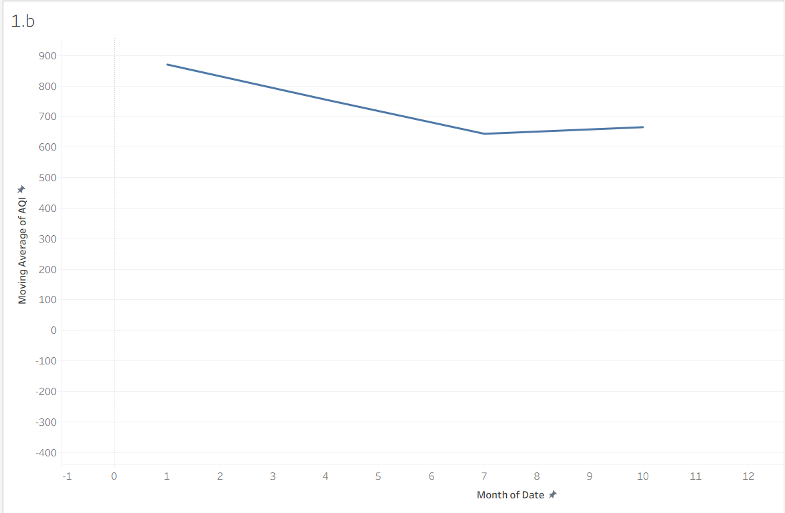

c) Design a choropleth-style map or grid for the temperature anomaly data, combined with an annotation on the
most extreme region. 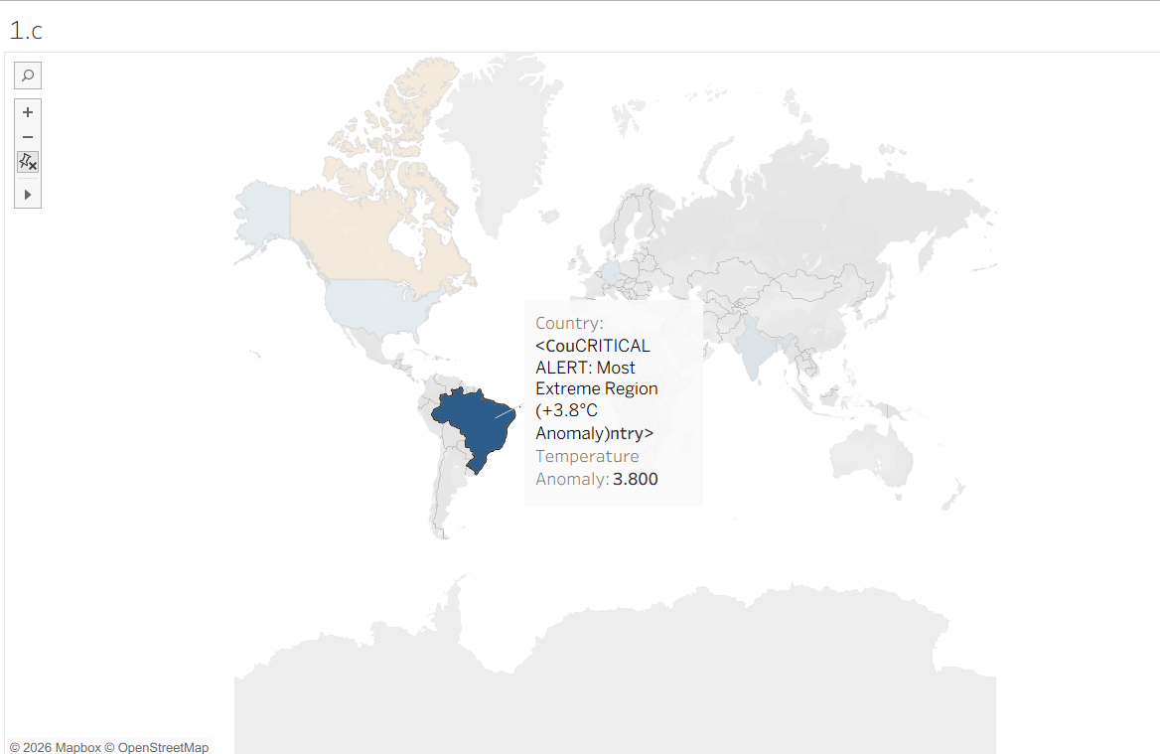
d) Justify your choice of chart for carbon emissions by sector, and explain why a treemap might be preferred over
a pie chart for this particular breakdown.
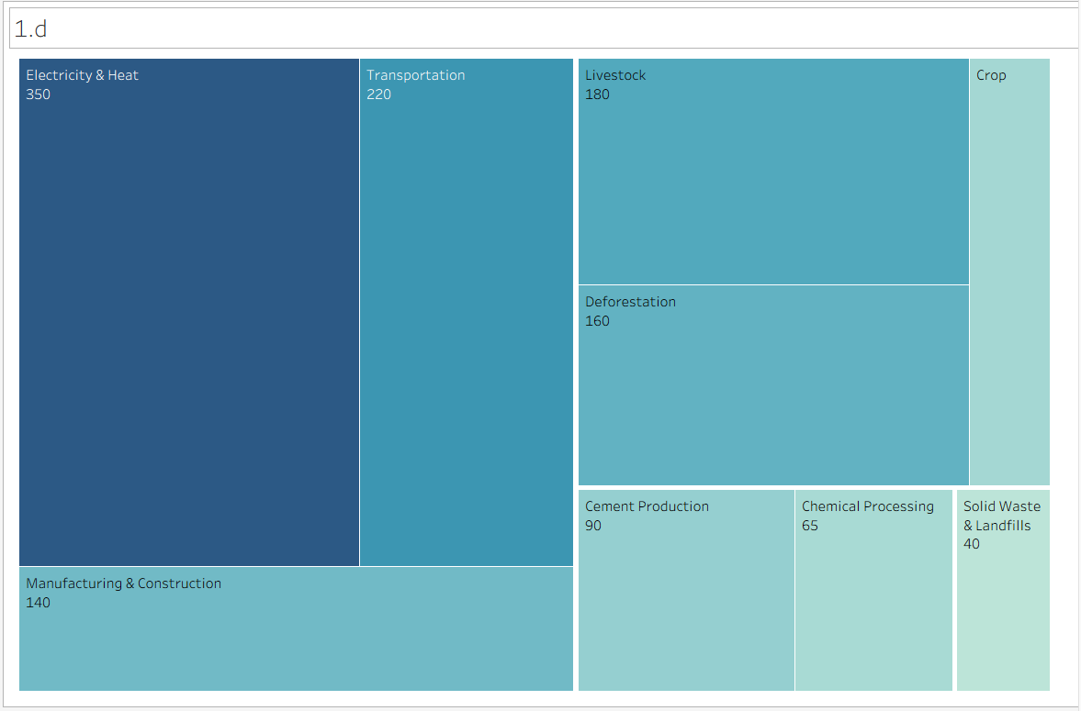

10.
a) What axis scale is appropriate for the district spending data, and why?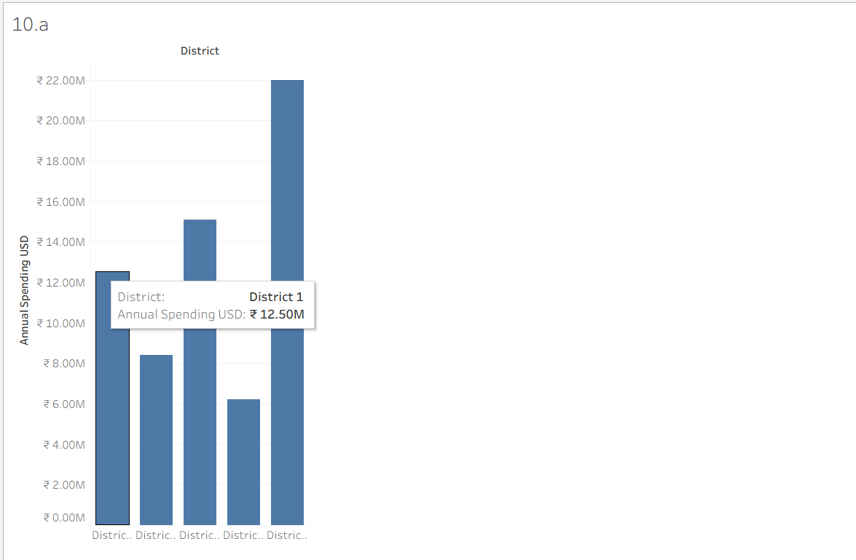
b) Which chart correctly represents the ordinal service-satisfaction categories while preserving their order? 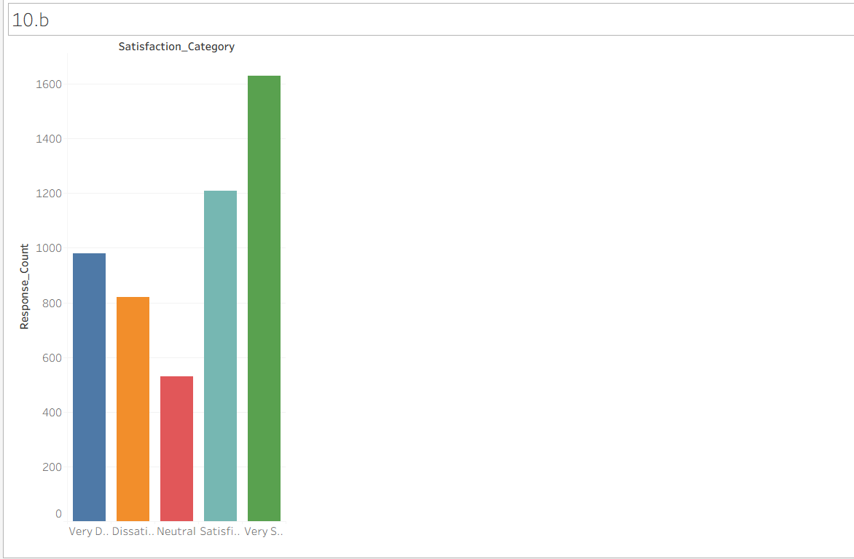

c) Propose a chart and color scale for the year-over-year spending change data (increases vs. decreases).

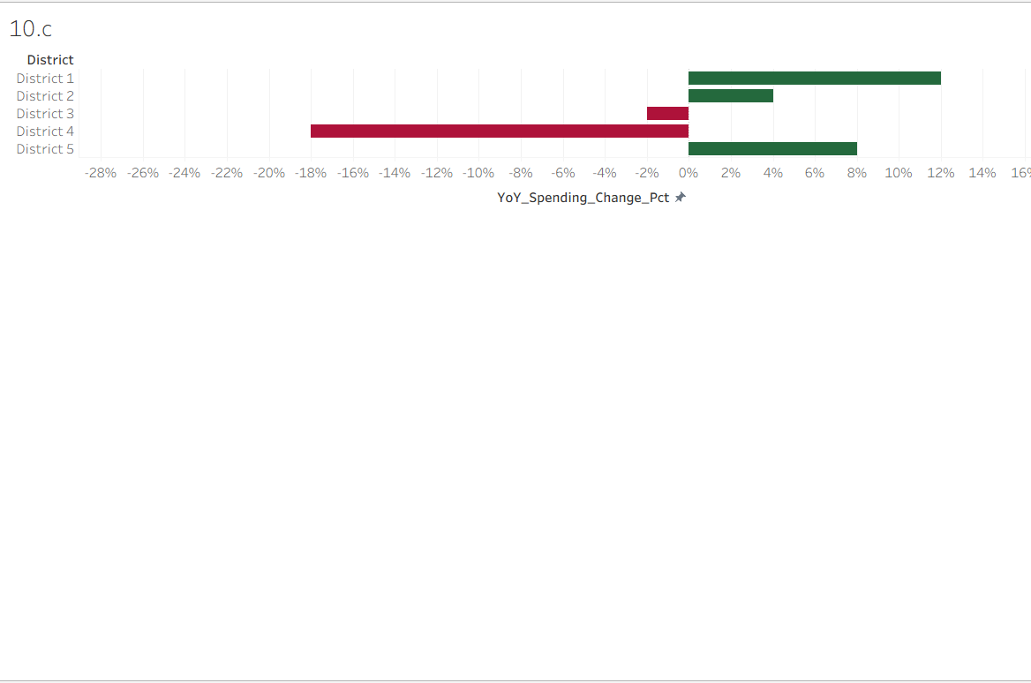d) Design a combined dashboard using two of the above views, with a narrative takeaway a city council member
could act on. 